|  |  |
| --- | --- |
| **NAME** | YOGESWARI M |
| **DEPARTMENT** | COMPUTER SCIENCE AND ENGINEERING |
| **COLLEGE** | DHANALAKSHMI SRINIVASAN INSTITUTE OF TECHNOLOGY |
| **COURCE** | DIGITAL MARKETING |
| **NM ID** | F62E82281221FD6A60247B9C3D0BF00A |

**ASSIGNMENT 1**

CREATE A BLOG OR WEBSITE USING BLOGSPOT AND WORDPRESS. CUSTOMIZE THE THEME DESIGN AND POST NEW ARTICLE WITH 500.LINK: <https://fascinatingfashions.blogspot.com/>

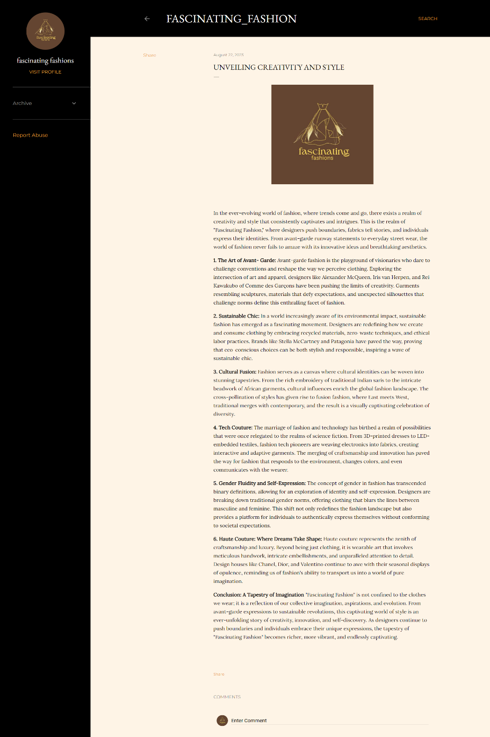

**ASSIGNMENT 2**

CREATE A NEW FACEBOOK BUISNESS PAGE AND POST ONE SOCIAL MEDIA POSTER FOR YOUR BRAND

LINK: <https://www.facebook.com/people/Page-Crafters/61550192768049/>

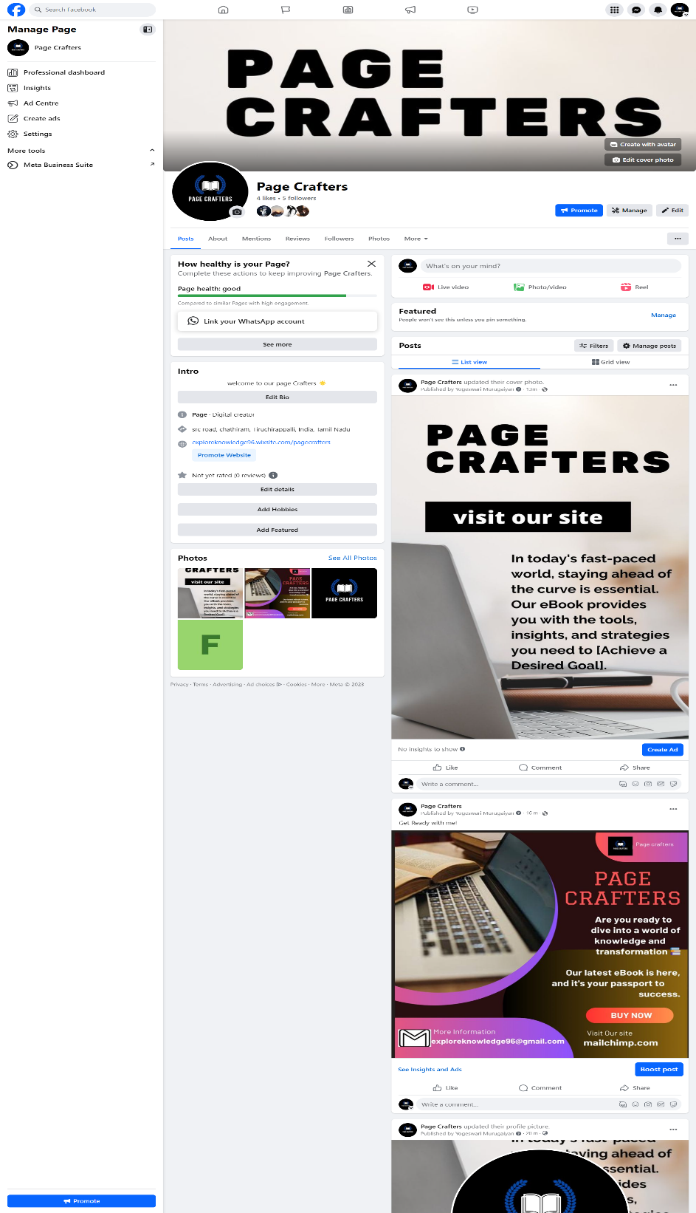

**ASSIGNMENT 3**

CRETE AND DESIGN A SOCIAL MEDIA ADVERTISMENT POSTER USING CANVA



**ASSIGNMENT 4**

CREATE EMAIL NEWSLETTER DESIGN USING MAILCHIMP OR CANVA TOOL.

LINK: <https://fascinatingfashions.blogspot.com/>

